[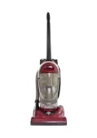](http://www.123rf.com/photo_14663243_old-used-red-vacuum-isolated.html?term=vacuum)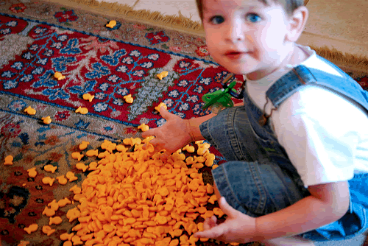

[](http://www.123rf.com/photo_26923395_cleaning-and-home-concept--close-up-of-male-brooming-wooden-floor-with-small-whisk-broom-and-dustpan.html?term=sweeping%20the%20floor)[](http://www.123rf.com/photo_27141126_smiling-man-cleaning-in-living-room-at-home.html?term=sweeping%20the%20floor)[](http://www.123rf.com/photo_22073401_little-boy-playing-with-mother-s-mobilephone-angry-mother-warning-with-finger.html?term=angry%20on%20%20cell%20phone)[](http://www.123rf.com/photo_6750889_father-talking-with-son-silhouette.html?term=parents%20talking%20to%20children)[](http://www.123rf.com/photo_4645900_mother-serving-a-meal-to-her-children-at-home.html)[](http://www.123rf.com/photo_6751024_parents-with-children-talking-silhouette.html?term=parents%20talking%20to%20children)[](http://www.123rf.com/photo_19381526_little-boy-pulls-the-cord-from-the-electrical-outlet.html?term=child%20with%20outlet)[](http://www.123rf.com/photo_19390590_mop-plastic-bucket-and-rubber-gloves-isolated-on-white.html?term=sweeping%20the%20floor)

[](http://www.123rf.com/photo_19390596_mop-plastic-bucket-and-rubber-gloves-isolated-on-white.html?term=sweeping%20the%20floor)

[](http://www.123rf.com/photo_9304643_profile-view-of-a-very-angry-man-screaming-isolated-on-white-background.html?term=yelling)



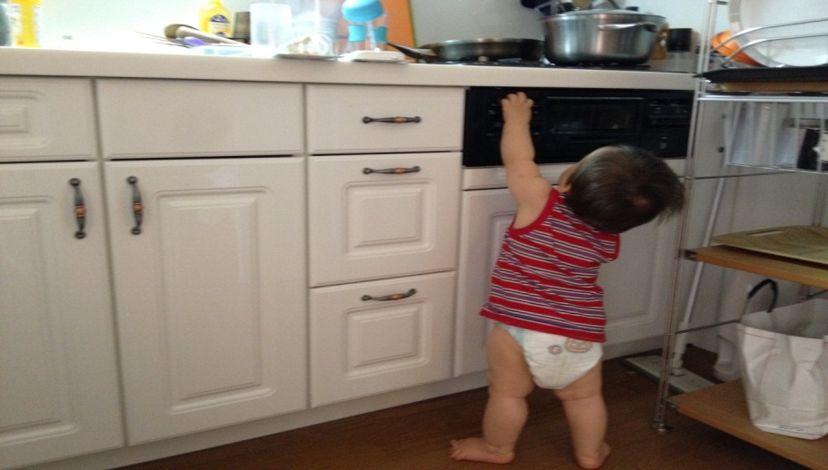

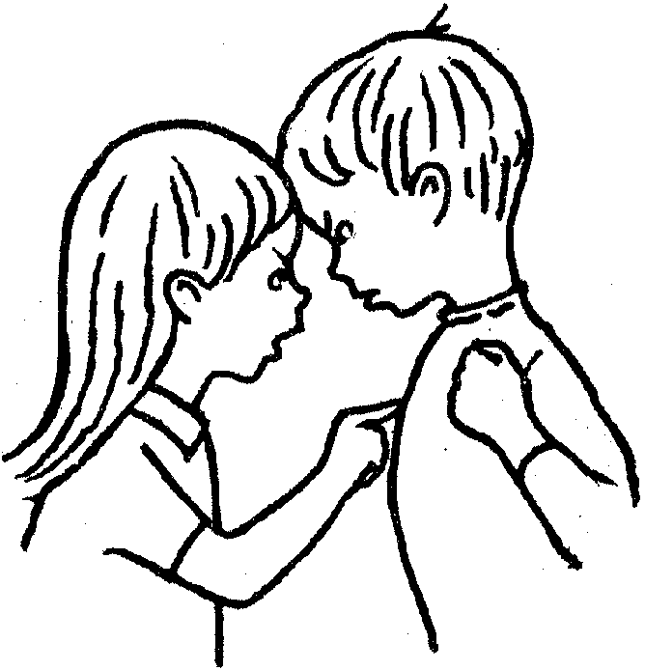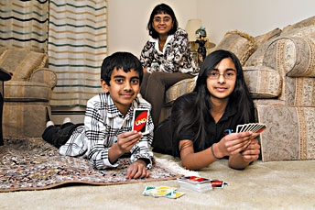

[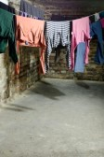](http://www.123rf.com/photo_28119281_clothes-on-clothesline-in-old-unhygenig-basement.html?term=laundry%20on%20the%20floor)

[](http://www.123rf.com/photo_19871412_happy-indian-father-and-daughter-at-home-on-sofa-together.html?term=parents%20talking%20to%20children)

[](http://www.123rf.com/photo_12037730_ethnic-father-talking-to-his-son-outside.html?term=parents%20talking%20to%20children)



[](http://www.123rf.com/photo_7014829_no-cell-phone-sign.html?term=%20cell%20phone)

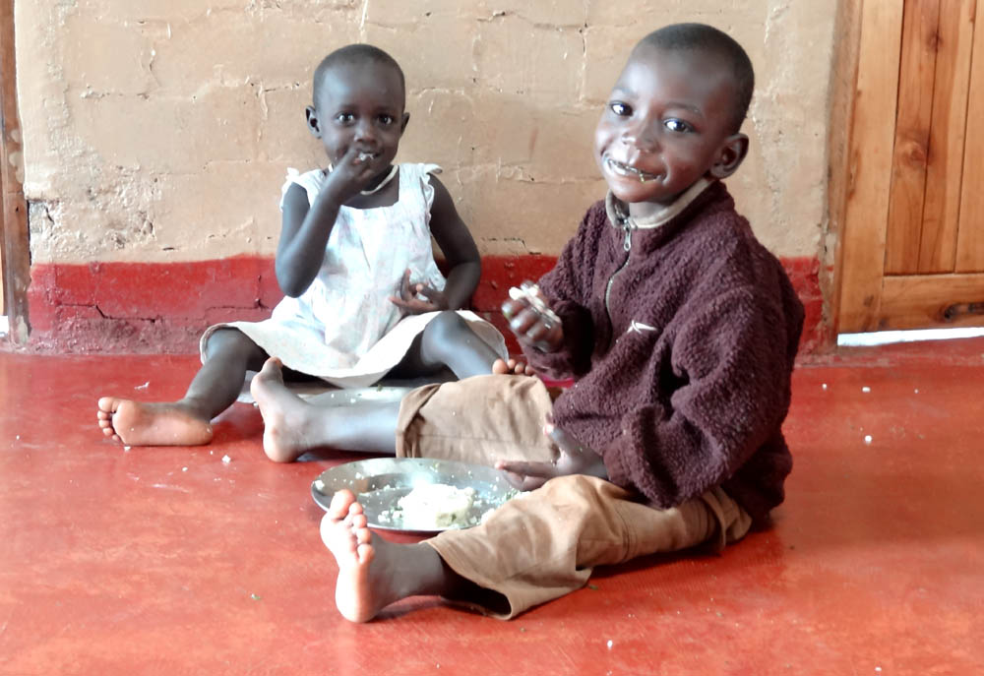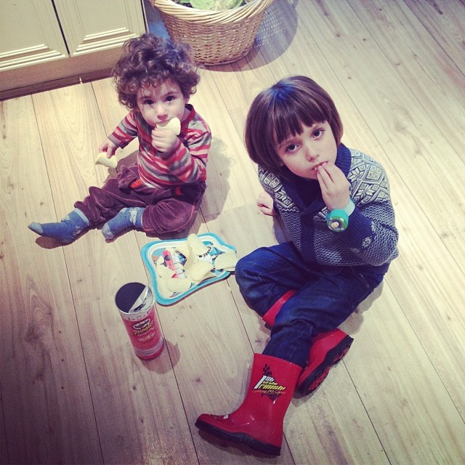













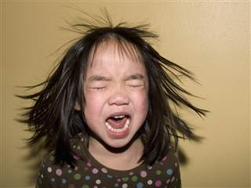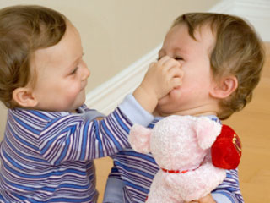

[](http://www.123rf.com/photo_8777589_angry-boy.html?term=yelling)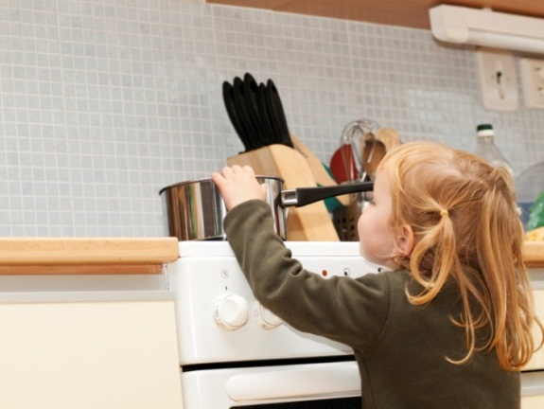







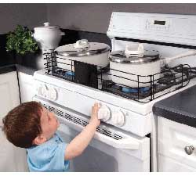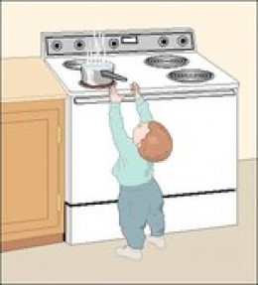

[](http://www.123rf.com/photo_7387777_multi-racial-family-at-breakfast.html?term=families%20eating%20at%20the%20table)

[](http://www.123rf.com/photo_8199333_an-image-of-a-person-taking-out-trash.html)



[](http://www.123rf.com/photo_11622272_portrait-of-a-young-woman-with-a-crazy-expresion-isolated-over-white-background.html?term=yelling)

[](http://www.123rf.com/photo_14890574_yelling-man.html?term=yelling)

[](http://www.123rf.com/photo_19522055_man-taking-garbage-out-of-can.html?term=taking%20out%20garbage)

[](http://www.123rf.com/photo_24607433_the-washing-clothes-in-the-of-blue-bowl.html?term=washing%20clothing)

[](http://www.123rf.com/photo_13131658_child-illustration-on-a-white-background.html?term=children%20eating%20at%20the%20table)

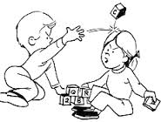**[](http://www.google.com/imgres?imgurl=http://www.nestlette.com/wp-content/uploads/2013/06/temper-tantrum.jpg&imgrefurl=http://www.nestlette.com/2013/06/taming-of-the-tantrum/&h=298&w=448&tbnid=1KALxXuoGhe_2M:&zoom=1&docid=JKmztp4N27PToM&ei=BsWgU8bzJY_zoATx5YHwBQ&tbm=isch&ved=0CDkQMygXMBc&iact=rc&uact=3&dur=131&page=2&start=19&ndsp=23)**[](http://www.123rf.com/photo_13131719_child-illustration-on-a-white-background.html?term=children%20eating%20at%20the%20table)



[](http://www.123rf.com/photo_2917325_a-mother-pulls-the-headphone-off-of-her-son-to-tell-him-something.html?term=yelling)



[](http://www.123rf.com/photo_15216100_kitchen-utensils-need-a-wash.html?term=washing%20dishes)

[](http://www.google.com/imgres?imgurl=http://www.slate.com/content/dam/slate/articles/double_x/doublex/2012/12/121206_DX_TemperTantrum.jpg.CROP.rectangle3-large.jpg&imgrefurl=http://www.slate.com/articles/double_x/doublex/2012/12/disruptive_mood_dysregulation_disorder_in_dsm_5_criticism_of_a_new_diagnosis.html&h=346&w=568&tbnid=7Qi9AaTRDLf5bM:&zoom=1&docid=0MqDrU4wEZwNyM&ei=YsSgU8CZAsHooAS9ioKIBg&tbm=isch&ved=0CD4QMyg2MDY4vAU&iact=rc&uact=3&dur=154&page=36&start=737&ndsp=21)**[](http://www.google.com/imgres?imgurl=http://www.slate.com/content/dam/slate/blogs/behold/2013/08/Jill%20Greenberg/9.jpg.CROP.original-original.jpg&imgrefurl=http://www.slate.com/blogs/behold/2013/08/04/jill_greenberg_end_times_crying_children_photos_became_a_headache_for_the.html&h=1095&w=920&tbnid=psi6mGbsoPvbRM:&zoom=1&docid=0wq9rj2XQPQSxM&ei=3cegU9K8BY7joATIn4CIDw&tbm=isch&ved=0CB0QMygBMAE&iact=rc&uact=3&dur=317&page=1&start=0&ndsp=16)[](http://www.google.com/imgres?imgurl=http://www.dianafit.com/wp-content/uploads/2012/09/tantrum-272x300.jpg&imgrefurl=http://www.dianafit.com/fear-is-a-liar/&h=300&w=272&tbnid=J2VtibonKnHbuM:&zoom=1&docid=tBwL-53wFdI2xM&ei=0MGgU-ytF828oQS0_4LgBA&tbm=isch&ved=0CCoQMygOMA4&iact=rc&uact=3&dur=1362&page=1&start=0&ndsp=18)**[](http://www.google.com/imgres?imgurl=http://images.agoramedia.com/wte3.0/gcms/Toddler-Bedtime-Battles-article.jpg&imgrefurl=http://www.whattoexpect.com/toddler-discipline/toddler-bedtime-battles.aspx&h=315&w=315&tbnid=WcaDaKxKE1NktM:&zoom=1&docid=yK3Ue_JHhyBosM&ei=pcKgU7O6M4_zoATx5YHwBQ&tbm=isch&ved=0CGEQMyhZMFk42AQ&iact=rc&uact=3&dur=230&page=33&start=674&ndsp=20)[](http://www.123rf.com/photo_12488850_an-image-of-a-man-using-a-vacuum-cleaner.html?term=vacuum)[](http://www.123rf.com/photo_14253757_illustration-of-a-girls-washing-plates-on-a-white-background.html?term=washing%20dishes)**[](http://www.google.com/imgres?imgurl=http://simplysheneka.files.wordpress.com/2013/10/kids.jpg&imgrefurl=http://simplysheneka.com/2013/10/05/tips-on-dating-a-man-with-children/&h=341&w=513&tbnid=NrWfRgPhAOmr-M:&zoom=1&docid=Vdk05t81_1BAWM&ei=IMGgU93TM8HooAS9ioKIBg&tbm=isch&ved=0CDsQMygzMDM4rAI&iact=rc&uact=3&dur=2152&page=16&start=330&ndsp=23)**[](http://www.123rf.com/photo_6813660_human-taking-the-trash-out--a-3d-image.html?term=taking%20out%20garbage)[](http://www.google.com/imgres?imgurl=http://0.tqn.com/d/babyparenting/1/G/b/m/tantrumthomasnorthcut.jpg&imgrefurl=http://babyparenting.about.com/od/tantrums/f/Can-A-Temper-Tantrum-Be-Harmful-To-My-Toddler.htm&h=240&w=160&tbnid=xcmfdxccHQ9RrM:&zoom=1&docid=rEsMkPODmunIsM&ei=0MGgU-ytF828oQS0_4LgBA&tbm=isch&ved=0CDwQMygXMBc&iact=rc&uact=3&dur=164&page=2&start=18&ndsp=22)[](http://www.123rf.com/photo_5198132_washing-dishes.html?term=washing%20dishes)**[](http://www.google.com/imgres?imgurl=http://a4.ec-images.myspacecdn.com/images01/41/63773245126439b3c62434eaad24e2df/l.jpg&imgrefurl=http://www.ineedaplaydate.com/2012_05_01_archive.html&h=214&w=300&tbnid=p1gZm-2VLF5-CM:&zoom=1&docid=gRYG6K8CZ9VOKM&ei=VMWgU8XvLI_doATR9oHgCw&tbm=isch&ved=0CEsQMyhDMEM4rAI&iact=rc&uact=3&dur=413&page=17&start=359&ndsp=25)**[](http://www.google.com/imgres?imgurl=http://www.conservativedailynews.com/wp-content/uploads/2012/11/no-whining.jpg&imgrefurl=http://www.conservativedailynews.com/2013/07/entitled-30-year-old-woman-throws-temper-tantrum-because-she-doesnt-get-her-way/&h=301&w=319&tbnid=Q0xv_dTooABZWM:&zoom=1&docid=z4-_36BFeEmpXM&ei=SMSgU660LtawoQSkqID4Cw&tbm=isch&ved=0CFgQMyhQMFA42AQ&iact=rc&uact=3&dur=247&page=33&start=678&ndsp=22)[](http://www.google.com/imgres?imgurl=http://operationstandbyyourman.weebly.com/uploads/1/2/3/2/12321921/9796139.jpg?472&imgrefurl=http://operationstandbyyourman.weebly.com/the-baby-bump-with-a-side-of-parenting.html&h=472&w=472&tbnid=b3MyKW58hRy3OM:&zoom=1&docid=n2yybs3O3J49UM&ei=wMWgU4OON4XroAS50IHIDQ&tbm=isch&ved=0CCYQMygeMB44vAU&iact=rc&uact=3&dur=49&page=35&start=727&ndsp=17)[](http://www.google.com/imgres?imgurl=http://cbskymx2.files.wordpress.com/2013/10/102510695-e1382387473939.jpg?w%3D620%26h%3D349%26crop%3D1&imgrefurl=http://kymx.cbslocal.com/2013/10/21/heres-what-you-do-when-your-kid-throws-a-massive-temper-tantrum/&h=349&w=620&tbnid=lgkiDULcXRGqyM:&zoom=1&docid=KTdxQTlsduQW_M&ei=0MGgU-ytF828oQS0_4LgBA&tbm=isch&ved=0CDsQMygWMBY&iact=rc&uact=3&dur=722&page=2&start=18&ndsp=22)[](http://www.google.com/imgres?imgurl=http://sg.theasianparent.com/wp-content/uploads/2011/02/shutterstock_260427131-e1361928976130.jpg&imgrefurl=http://sg.theasianparent.com/defuse-tantrums-with-these-tantrum-stoppers/&h=325&w=333&tbnid=Uk-FyumHkB2vHM:&zoom=1&docid=al1dIQnv5V_azM&ei=oL-gU7D5EsWCogSr34CYDw&tbm=isch&ved=0CGMQMyhBMEE&iact=rc&uact=3&dur=343&page=4&start=58&ndsp=22)[](http://www.google.com/imgres?imgurl=http://thegospelcoalition.org/blogs/tgc/files/2013/10/huff-shutterstock_57014537-231x300.jpg&imgrefurl=http://thegospelcoalition.org/article/dont-tell-me-your-kids-sins&h=300&w=231&tbnid=c6kELOCoJ56xsM:&zoom=1&docid=f5E2jSKNYwoJmM&ei=oL-gU7D5EsWCogSr34CYDw&tbm=isch&ved=0CFYQMyg0MDQ&iact=rc&uact=3&dur=433&page=3&start=40&ndsp=18)[](http://www.google.com/imgres?imgurl=http://nurtureparenting.com/wp-content/uploads/2013/09/tantrum1.jpg&imgrefurl=http://fearlessparent.org/is-your-difficult-child-actually-hypoglycemic/&h=1063&w=1600&tbnid=qPnF2GMCRGVLRM:&zoom=1&docid=eqkyQ0C2pNKtjM&ei=oL-gU7D5EsWCogSr34CYDw&tbm=isch&ved=0CGcQMyhFMEU&iact=rc&uact=3&dur=574&page=4&start=58&ndsp=22)